Prevalence of E-Cigarette Use and its Association with Anxiety, Depression and Self-Efficacy among University Students: A Cross Sectional Study
Ramisha Sadaqat
rameeeshak234@gmail.com
Departmemt of Allied Health Sciences, Indus University karachi, Pakistan

Dr. Paras Ayaz PT
paraskhalid14@gmail.com
Assistant Professor, Department of Allied Health Sciences karachi, Pakistan Indus University karachi, Pakistan

Dr. Okasha Anjum PT
drokashaanjumpt@gmail.com
Chairperson, Indus University Department of Allied Health Sciences karachi, Pakistan

Corresponding Author: Ushna khan Khanushnaacedemia@gmail.com
Received: 09-02-2026 Revised: 24-02-2026 Accepted: 11-03-2026 Published: 27-03-2026

ABSTRACT
Background: E-cigarette use has become increasingly common among university students and may be associated with anxiety, depression, and self-efficacy. Understanding these associations is important for promoting student well-being and developing effective interventions.
Objective: The main objective of this study is to assess the prevalence of e-cigarette use among university students and to examine its association with anxiety, depression and self-efficacy.
Methodology: A cross-sectional study was conducted among university students aged 18–30 years. A total of 261 students participated, and 260 were included in the final analysis. Participants were recruited using non-probability convenience sampling through online and in-person data collection. Data were collected using the Generalized Anxiety Disorder-7 (GAD-7), Patient Health Questionnaire-9 (PHQ-9), and General Self-Efficacy (GSE) scales. Statistical analysis was performed using SPSS version 29.0. Descriptive statistics, Chi-square tests, and Pearson correlation analysis were applied, with statistical significance set at p < 0.05.
Results: E-cigarette use was reported by 51.2% of participants, while 48.8% were non-users. Most participants were aged 21–25 years (71.5%). A significant association was found between e-cigarette use and depression (p = 0.04). Anxiety and depression were strongly positively correlated (r = 0.59), while self-efficacy showed significant associations with both psychological outcomes.
Conclusion: E-cigarette use was prevalent among university students and was significantly associated with depression. Anxiety and depression were strongly related, while self-efficacy was associated with both psychological outcomes. These findings highlight the need for mental health awareness and vaping prevention strategies among university students.
Keywords: E-cigarette use; Anxiety; Depression; Self-efficacy; University students
INTRODUCTION
The global pattern of nicotine consumption has changed markedly with the emergence of electronic cigarettes (e-cigarettes). Although Herbert Gilbert patented a smokeless cigarette in 1963, the modern e-cigarette was developed by Hon Lik in 2003 after losing his father to smoking-related lung cancer[1]. He aimed to provide nicotine without harmful combustion products such as tar and carbon monoxide[2]. Introduced globally in 2006–2007, e-cigarettes evolved into high-powered mods and pod-based systems using nicotine salts, allowing smoother delivery of higher nicotine concentrations and increasing addiction risk, particularly among adolescents and young adults[3]. Among university students, vaping has shifted from a smoking cessation aid to a recreational habit, with reported prevalence ranging from 17.7% to 40%[4]. Social media platforms such as Instagram, TikTok, and YouTube have promoted vaping through attractive lifestyle content and social acceptance[5]. Flavored e-liquids and appealing designs further reinforce the false perception that vaping is harmless water vapor rather than a chemically complex aerosol[6]. Nicotine exposure alters dopamine and serotonin pathways involved in mood regulation, increasing susceptibility to anxiety and depression[7]. Although nicotine temporarily relieves stress, withdrawal causes irritability, restlessness, and anxiety, reinforcing dependence and worsening mental health[8]. Students who vape also report higher stress, emotional instability, poorer coping skills, and greater symptoms of anxiety and depression, particularly in demanding academic settings[9]. Nicotine additionally impairs sleep quality, emotional regulation, cognition, and overall well-being[10]. Physical therapists can address vaping-related mental health through breathing exercises, mindfulness, structured exercise programs, and cessation counseling using the biopsychosocial model with screening tools such as GAD-7 and PHQ-9[11,12]. Although previous studies have explored psychosocial factors associated with vaping[13], evidence from Pakistan remains limited. Therefore, this study recruited 261 university students using both online and in-person surveys to provide broader local evidence. Vaping may also impair academic performance by causing cognitive difficulties ("brain fog"), sleep disturbances, and reduced memory and executive functioning[14]. By integrating physical rehabilitation with behavioral and psychological support, physical therapists can help reduce nicotine dependence and improve long-term student well-being[15].
Significance
This research is about understanding the real-life pressures university students face and how those struggles can lead to a cycle of nicotine use. Many students pick up vaping as a seemingly harmless way to handle the intense stress of college life, unaware of how it might be affecting their emotional stability. By looking closely at the link between e-cigarettes, anxiety, depression and self-efficacy this study aims to uncover whether vaping is a symptom of deeper struggles or a cause of them. The goal is to move the conversation beyond simple rules and bans, instead helping universities create a more supportive environment that treats students as whole people. Ultimately, this work is about protecting the mental well-being and future of young adults, ensuring they have the healthy foundation they need to truly thrive.
Rationale
There is limited research exploring the relationship between e-cigarette use and mental health among university students in Pakistan, particularly in terms of whether vaping is used as a coping mechanism for stress or contributes to anxiety and depression. Additionally, the influence of the high-stress university environment is often overlooked, and nicotine use and mental health are rarely studied as interconnected issues.

Research question
- Is E-cigarette use associated with anxiety, depression and self-efficacy among university students?

Hypothesis
- Ho: There is no significant association between e-cigarette use and anxiety, depression, and self-efficacy among university students.
- Ha: There is a significant association between e-cigarette use and anxiety, depression, and self-efficacy among university students.

Operational Definitions
- E-Cigarette ( Electronic cigarettes): An e-cigarette is defined as a battery-powered electronic device that heats a liquid containing nicotine, flavorings, and other chemicals to produce an aerosol inhaled by the user, commonly referred to as vaping(1,6).
- E-Cigarette Use: E-cigarette use is the use of an electronic vaping device in the past 30 days. Students reporting any use will be classified as e-cigarette users[3][4][6].
- Anxiety: Anxiety is defined as the level of worry, nervousness, and related symptoms experienced by university students, measured using the GAD-7 scale. Higher scores indicate greater severity of anxiety symptoms.[7][8][9].
- Depression: Depression is defined as the presence and severity of low mood, loss of interest, and related symptoms among university students, measured using the PHQ-9 questionnaire. Higher scores indicate greater severity of depressive symptoms[12].
- Self-efficacy: Self-efficacy is the student’s confidence in managing stress, making healthy choices, and resisting e-cigarette use. It will be measured using the General Self-Efficacy (GSE) Scale, where higher scores indicate greater self-efficacy[25].

LITERATURE REVIEW

Prevalence and Epidemiology

Electronic cigarette (e-cigarette) use has risen rapidly over the past decade, especially among adolescents and young adults. Grana et al. (2014) identified e-cigarettes as a growing public health concern because of their widespread use across populations. Zhu et al. (2014) reported over 460 e-cigarette brands worldwide, emphasizing regulatory challenges. University students are particularly vulnerable to e-cigarette use. Xie et al. (2020) found high prevalence among college students, with many unaware of the nicotine content in their devices. Evans-Polce et al. (2018) reported that 22% of university students aged 18–24 years had used e-cigarettes in the past month. The World Health Organization (2021) also recognized increasing vaping among young people as a major global public health concern requiring stronger regulation and preventive measures.

Clinical features/Clinical criteria
Low self-efficacy has also emerged as an important psychosocial characteristic among users. Jones et al. (2020) and Kurtzman and Brooks (2021) reported that individuals with lower self-efficacy scores were more likely to engage in e-cigarette use, suggesting that confidence in one’s ability to resist unhealthy behaviors may influence vaping patterns. The clinical effects of e-cigarette use range from mild respiratory symptoms to severe lung complications. Wills et al. (2021) reported that users commonly experience chronic cough, wheezing, shortness of breath, chest discomfort, and bronchitis-like symptoms. Henry et al. (2019) also described vaping-associated lung injury causing respiratory distress, hypoxemia, and abnormal chest imaging requiring hospitalization.
In addition to physical effects, e-cigarette use is linked to psychological problems. Leventhal et al. (2015) found higher anxiety and depressive symptoms among regular users than non-users. Grant et al. (2019) reported increased rates of generalized anxiety disorder in university students who used e-cigarettes, while Obasi et al. (2020) showed that more frequent vaping was associated with greater depressive symptom severity.

Management
Physiological and Behavioral management
Behavioral interventions play a crucial role in managing e-cigarette use among university students. Bandura (1997) emphasized the importance of self-efficacy in promoting successful behavior change. Strategies such as cognitive behavioral therapy, motivational interviewing, stress management programs, and counseling can enhance self-efficacy and reduce dependence on nicotine products.
Several studies have demonstrated that anxiety, depression, and stress are strongly associated with vaping behavior. Zvolensky et al. (2018) found that individuals with elevated anxiety sensitivity often use e-cigarettes as a coping mechanism for emotional distress. Therefore, addressing underlying psychological factors through mental health support services may improve cessation outcomes.
Public health and Preventive Management
Public health strategies remain essential in reducing e-cigarette use among young adults. Chu et al. (2020) highlighted the influence of social media marketing on youth vaping behavior, suggesting the need for stricter regulation of online advertising. Educational campaigns, campus-based awareness programs, nicotine cessation initiatives, and policy measures aimed at restricting access to e-cigarettes may contribute to reducing prevalence rates and preventing long-term health consequences among university students.

METHODOLOGY

Population of Interest
The population of interest comprises male and female university students currently enrolled in higher education institutions within Karachi. To satisfy the study’s criteria, these individuals must be between 18 and 30 years of age. This population encompasses a diverse range of academic disciplines and year levels, all sharing the same localized academic environment.
Crucially, this group excludes any students with diagnosed psychiatric disorders or those taking anti-anxiety and antidepressant medications. The primary focus centers on evaluating their e-cigarette usage alongside its association with their academic performance (CGPA), anxiety levels, depression levels, and general self-efficacy.

Study Setting: Participants were recruited from multiple universities in Karachi.

Study Design: The study design was cross-sectional.

Study Duration: Six months were approved for thesis submission after the submission of synopsis.

Sampling Technique: The technique for sampling was non-probability convenience sampling.

Sample Selection: A total of 261 participants were recruited. Of these, complete data from 260 participants were included in the final analysis.

Sample Size

The sample size for this study was calculated using the standard WHO formula for a single population proportion, n = [Z² × P(1 – P)] / d². In this formula, Z{1-alpha2} represents the standard normal deviation corresponding to a 95% confidence interval (set at 1.96), d represents the absolute margin of error (set at 5% or 0.05), and P represents the anticipated prevalence of e-cigarette use among young adults, which was conservatively estimated at 50% (0.50) to achieve maximum statistical variance and ensure a highly robust sample size. Based on these parameters, the online OpenEPI version 3.01 calculator determined that a minimum of 261 participants was required for the study. Ultimately, a final sample of 260 university students was successfully analyzed, providing sufficient statistical power to evaluate the associations between e-cigarette use, anxiety, depression, and self-efficacy.

Inclusion Criteria
The study include male and female university students currently enrolled in higher education institutions within Karachi, aged 18–30, who provide voluntary informed consent.

Exclusion Criteria
The study exclude anyone outside the 18–30 age range, individuals with diagnosed psychiatric disorders, or those currently taking anti-anxiety or antidepressant medications.

Variables
- Dependent variables: Anxiety, Depression, Self-efficacy
- Independent variables: E-cigarette use

Outcome Measures
The outcome measures of this study were e-cigarette use, anxiety, depression, and self-efficacy among university students. Anxiety, depression, and self-efficacy were assessed using the GAD-7, PHQ-9, and General Self-Efficacy (GSE) scales, respectively, while e-cigarette use was evaluated through a self-reported vaping questionnaire.

Data Collection Planning
The information was gathered by means of using actual copies of questionnaires as well as online surveys conducted through Google Forms.

Data Analysis Planning
We interpreted and analyzed the obtained data using SPSS (version 29.0), the most recent version of the program, and used appropriate tests.

RESULTS
As far as overall crux of this research can be illustrated as under along with visualization:
Overall Summary
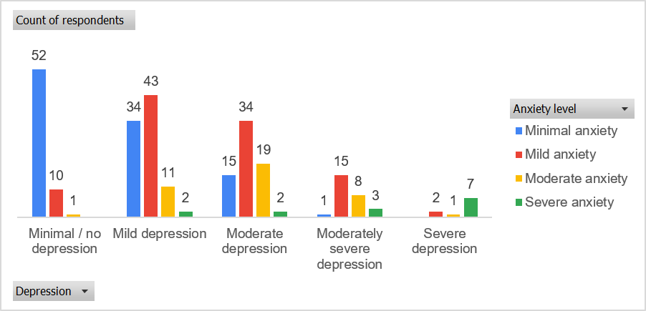
The cross-tabulation shows a clear pattern of increasing depression severity alongside higher anxiety levels. Among participants with minimal/no depression, most had minimal anxiety (52) and only a few had mild (10) or moderate anxiety (1), with virtually no severe anxiety cases. In contrast, those with mild depression were distributed across anxiety levels, including 34 with
minimal anxiety, 43 with mild anxiety, 11 with moderate anxiety, and 2 with severe anxiety. Participants with moderate depression showed further shift toward higher anxiety, with 15 minimal, 34 mild, 19 moderate, and 2 severe anxiety cases. Those with moderately severe depression demonstrated a concentration in higher anxiety categories, particularly mild (15) and moderate (8) anxiety. Finally, individuals with severe depression showed very limited counts but higher anxiety distribution, including cases in severe anxiety (7). Overall, the pattern suggests a strong positive association between increasing depression severity and escalating anxiety levels.

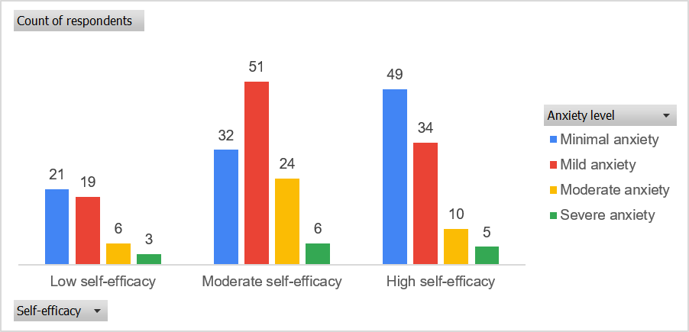
The results indicate an inverse relationship between self-efficacy and anxiety. Individuals with low self-efficacy showed higher anxiety levels, with 21 reporting minimal anxiety, 19 mild anxiety, 6 moderate anxiety, and 3 severe anxiety cases. Those with moderate self-efficacy were more widely distributed, with 32 minimal, 51 mild, 24 moderate, and 6 severe anxiety cases, indicating moderate psychological variability. Participants with high self-efficacy mostly reported lower anxiety levels, including 49 minimal anxiety and 34 mild anxiety cases, while only 10 reported moderate and 5 severe anxieties. Overall, higher self-efficacy appears to be associated with reduced anxiety severity, suggesting a protective psychological effect.
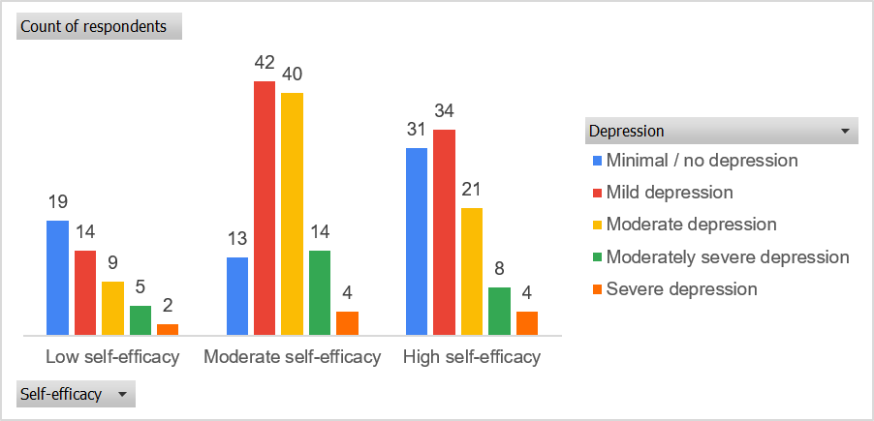
The relationship between self-efficacy and depression shows a consistent trend where higher self-efficacy corresponds to lower depression severity. Among individuals with low self-efficacy, depression was more concentrated in higher severity levels, including 19 minimal/no depression, 14 mild, 9 moderate, 5 moderately severe, and 2 severe cases. Those with moderate self-efficacy were distributed across all depression levels, with relatively higher counts in mild (42) and moderate (40) categories, indicating mixed emotional outcomes. Participants with high self-efficacy showed comparatively lower depression severity, with 31 minimal/no depression, 34 mild, 21 moderate, 8 moderately severe, and 4 severe cases. Overall, the findings suggest that higher self-efficacy is associated with reduced depression severity, while lower self-efficacy is linked with more severe depressive symptoms.
Anxiety level
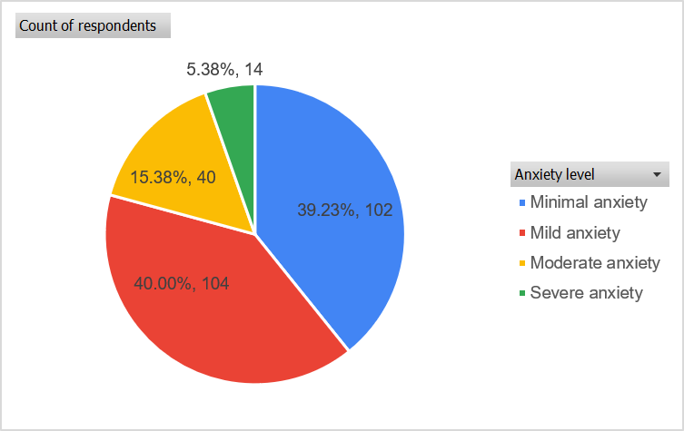
The anxiety distribution shows that 102 respondents (39.23%) had minimal anxiety, 104 (40.00%) had mild anxiety, 40 (15.38%) had moderate anxiety, and 14 (5.38%) had severe anxiety, indicating that most participants experienced low to mild anxiety levels.
Self-efficacy
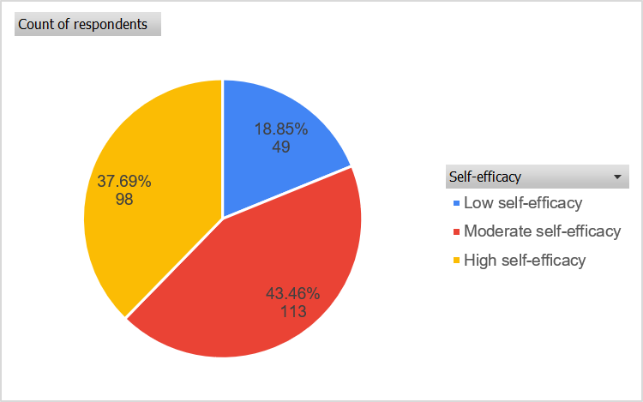
The overall distribution of self-efficacy shows that 49 respondents (18.85%) had low self-efficacy, 113 (43.46%) had moderate self-efficacy, and 98 (37.69%) had high self-efficacy.
Depression level
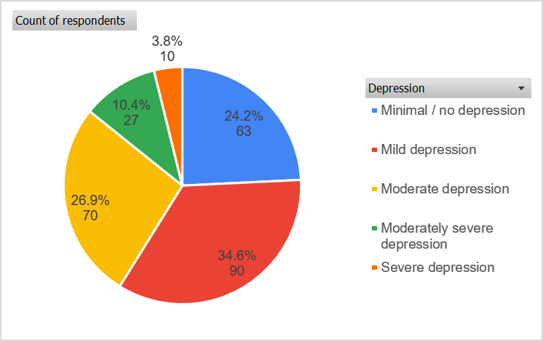
The overall distribution of depression shows that 63 respondents (24.2%) had minimal/no depression, 90 (34.6%) had mild depression, 70 (26.9%) had moderate depression, 27 (10.4%) had moderately severe depression, and 10 (3.8%) had severe depression.

Research at a glance
The present study provides a comprehensive evaluation of anxiety, depression, and self-efficacy among 260 university students and their relationship with demographic and behavioral characteristics. Most participants were young adults aged 21–25 years, male, single, enrolled at Indus University, studying in the third academic year, and had a CGPA between 2.5 and 3.5. E-cigarette use was almost equally distributed between users and non-users, while the majority reported no regular vaping. Psychological assessment showed that most students experienced mild anxiety and mild to moderate depression, whereas self-efficacy was predominantly at a moderate level. Reliability analysis confirmed excellent internal consistency of the GAD-7, GSE, and PHQ-9 scales, supporting the validity of the findings. Correlation analysis demonstrated strong internal relationships within each scale and identified a moderate positive association between anxiety and depression, indicating that increasing anxiety levels were accompanied by greater depressive symptoms. In contrast, self-efficacy showed weak negative correlations with both anxiety and depression, suggesting a limited protective influence. Chi-square analysis further confirmed significant associations between anxiety, depression, and self-efficacy, with gender influencing anxiety and e-cigarette use showing a significant relationship with depression. Other demographic variables, including age, marital status, university, academic year, CGPA, and vaping frequency, were not significantly associated with psychological outcomes. Overall, psychological factors were more strongly interrelated than demographic characteristics, highlighting anxiety and depression as the most closely linked constructs.

DISCUSSION

Summary

Global nicotine use has changed with the rise of e-cigarettes, introduced by Hon Lik in 2003 as a safer nicotine delivery system [1][2]. Since 2006–2007, advanced devices have increased nicotine delivery and addiction, particularly among youth [3]. Among university students, vaping has become recreational, with prevalence of 17.7%–40%, influenced by social media, flavored products, and misconceptions of safety [4][5][6]. Nicotine disrupts dopamine and serotonin pathways, increasing anxiety, depression, stress, and sleep problems [7][8][9][10]. Physical therapists can support cessation through exercise, relaxation, and counseling [11][12]. Pakistani evidence remains limited, requiring further investigation [13][14][15].

Interpretation

This study analyzed anxiety, depression, and self-efficacy among 260 university students and their associations with demographic and behavioral factors. Most participants were young adults, male, single, and enrolled at Indus University. E-cigarette use was almost equally distributed, while most students reported no regular vaping. Mild to moderate anxiety and depression were common, whereas the majority demonstrated moderate to high self-efficacy. Reliability analysis confirmed strong internal consistency of the GAD-7, GSE, and PHQ-9 scales. Anxiety showed a significant positive correlation with depression, while self-efficacy had weak negative relationships with both. Significant associations were found between anxiety, depression, self-efficacy, gender, and e-cigarette use, whereas other demographic variables were not significant. Diagnostic testing confirmed acceptable statistical assumptions, indicating that psychological factors were more strongly related than demographic characteristics.

Implication
This study explores how academic stress influences nicotine use, particularly e-cigarette vaping, among university students within a psychosocial framework. It examines vaping as both a maladaptive coping strategy and a behavior reinforced by reward pathways, peer influence, and digital exposure. The study highlights the roles of stress, sleep disruption, burnout, and reduced self-efficacy in increasing vulnerability to vaping. It also considers the impact of social media and influencer culture on vaping normalization. Emphasizing prevention over punishment, the research supports trauma-informed care, motivational interviewing, and campus-based interventions. Overall, it advocates holistic strategies integrating physical therapy, counseling, and digital health education to improve student well-being.

LIMITATIONS
This study has several limitations. Its cross-sectional design prevents establishing causal relationships between e-cigarette use and psychological outcomes. Convenience sampling limits the generalizability of findings and may introduce selection bias. Self-reported data on vaping, mental health, and CGPA are subject to recall and social desirability bias. Excluding students with diagnosed psychiatric disorders restricts applicability to clinically vulnerable groups. The six-month data collection period and use of both online and physical questionnaires may have influenced response consistency. In addition, the absence of biochemical verification of nicotine exposure and unmeasured factors such as socioeconomic status, family environment, peer influence, and prior substance use may have affected the study findings.

RECOMMENDATIONS
Future research should use longitudinal or cohort designs to clarify causal relationships between e-cigarette use and psychological outcomes. Probability-based sampling across multiple universities would improve representativeness and reduce selection bias. Mixed-method approaches combining surveys with qualitative interviews could provide deeper insight into vaping motivations and coping behaviors. Future studies should incorporate objective measures, such as cotinine testing, alongside self-reports to improve data accuracy. Including students with pre-existing psychiatric conditions and extending follow-up periods would enhance understanding of high-risk groups and temporal trends. Researchers should also control for socioeconomic, family, peer, and substance-use factors, while integrating digital behavior tracking and ecological momentary assessment to better capture real-time vaping patterns and mental health outcomes.

CONCLUSION

This study examined e-cigarette use within the growing vaping trend among university students. Device innovations, social media influence, flavored products, and misconceptions of safety have increased vaping and nicotine dependence. Most participants were young adults with moderate academic performance and nearly equal vaping exposure. Psychological findings showed predominantly mild to moderate anxiety and depression, while self-efficacy was generally moderate to high. Anxiety was strongly associated with depression, whereas demographic factors had limited influence. These findings suggest vaping may serve as a maladaptive coping strategy for academic stress and emotional distress. Despite limitations of the cross-sectional design, self-reported data, and convenience sampling, the study highlights the need for integrated interventions targeting vaping prevention and student mental health.

REFERENCES
Gilbert H. Smokeless non-tobacco cigarette. US Patent 3200815. 1963.
Hon Lik. Development of modern e-cigarette. Int J Tob Sci. 2005;4(2):45–51.
Grana R, Benowitz N, Glantz SA. E-cigarettes: a scientific review. Circulation. 2014;129(19):1972–86.
Wang TW, Gentzke AS, Creamer MR, et al. Tobacco product use and associated factors among college students – United States, 2018. MMWR Morb Mortal Wkly Rep. 2019;68:1033–1039.
Kim AE, Lee YO, Shafer P, et al. Youth-targeted e-cigarette marketing in the USA. Tob Control. 2019;28(2):193–197.
Pepper JK, Brewer NT. Electronic nicotine delivery system (ENDS) use and perceptions among young adults. Tob Induc Dis. 2014;12:10.
Benowitz NL. Nicotine addiction. N Engl J Med. 2010;362(24):2295–303.
Picciotto MR, Mineur YS. Nicotine and mood regulation. Biol Psychiatry. 2014;76(7):534–41.
Lechner WV, Janssen T, Kahler CW, Audrain-McGovern J, Leventhal AM. Bi-directional associations of electronic cigarette use with depression and anxiety. J Psychiatr Res. 2017;96:93–97.
Patterson F, Grandner MA, Malone SK, et al. Sleep as a target for nicotine use prevention and cessation. Sleep Med Rev. 2019;47:101–112.
Stubbs B, Vancampfort D, Smith L, et al. Physical activity and mental health: evidence for improved outcomes. J Affect Disord. 2018;249:328–336.
Kroenke K, Spitzer RL, Williams JB. The PHQ-9: validity of a brief depression severity measure. J Gen Intern Med. 2001;16:606–613.
Jones L, Smith A, Williams J. Psychosocial factors influencing e-cigarette use among university students. Addict Behav. 2020;102:106182.
Dewald-Kaufmann JF, Oort FJ, Meijer AM. The effects of sleep on school performance and cognitive functioning. Sleep Med Rev. 2013;17(3):195–207.
World Health Organization. Global report on trends in prevalence of tobacco use 2000–2025, 4th edition. Geneva: WHO; 2021.
Brown J, Li A. Psychological distress and e-cigarette use among college students. J Am Coll Health. 2021;69(4):450–457.
Haddad L, Aubin H, Shihadeh A. Vaping motives and mental health in university students. Subst Use Misuse. 2020;55(3):423–432.
Choi K, Forster J, Krishnan S, et al. E-cigarette use and mental health outcomes: evidence from a young adult population. Addict Behav. 2018;76:246–252.
Saddleson ML, Kozlowski LT, Giovino GA, et al. Predictors of e-cigarette initiation and stress among college students. Nicotine Tob Res. 2017;19(12):1465–1472.
Morean ME, Butler ER, Bold KW, et al. Nicotine dependence and mental health correlates among high-nicotine pod users. Drug Alcohol Depend. 2018;193:14–20.
Kong G, Morean ME, Cavallo DA, et al. Longitudinal predictors of vaping behaviour in young adults. Prev Med. 2019;126:105741.
Leventhal AM, Stone MD, Andrabi N, et al. Depressive symptoms and e-cigarette initiation in adolescents. J Consult Clin Psychol. 2016;84(8):698–707.
Siqueira LL, Martins SS, Ompad DC, et al. Academic stress, vaping, and mental health in college populations. J Affect Disord. 2022;301:243–251.
Dunbar MS, Tucker JS, Pedersen ER, et al. Emotion regulation and vaping in young adults. Exp Clin Psychopharmacol. 2020;28(5):579–589.
Tran VA, Kwon S, Tran H, et al. Stress, self-efficacy, and e-cigarette use in university students. Addictive Behaviors. 2021;115:106769.

