

**ACADEMIA Health Sphere Journal**

**DOI: 10.63056/ACAD.001.04**

**Mosquities Species Diversity of the Districts (Punjab, Baluchistan, Sindh and Kpk) Pakistan**

**Ayesha Umer a**

a Bahawal Victoria Hospital, Pakistan

**Correspondence:** Ayesha Umer ([ayeshasarwar2012@gmail.com](mailto:ayeshasarwar2012@gmail.com))

**Received:** 14 Feb 2025 | **Revised:** 5 March 2025 | **Accepted:** 21 March 2025

**ABSTRACT**

This study is essential for the identification of mosquito fauna in Pakistan studied here. This species diversity is reported from some of the districts of Pakistan (Punjab, Baluchistan, Sindh, and KPK). The long and short diameter of the eye, abdomen, length, and width of the head, and thorax size and shape in millimeters were measured to develop for species differentiation and identification. According to the literature, the mosquito fauna of Pakistan includes about 42 different species of mosquitoes found in Pakistan. A further 26 species are Oriental, Palearctic, Holarctic, and Ethiopian Cosmo tropophysical. The species described from localities now within Pakistan and from our collections are recorded in the present work. It lists 10genera and 91 species from West Pakistan and 13 genera and 89 species from East Pakistan. The common genera of mosquitoes newly described are Anopheles, Aedes, and Culex. Mosquitoes are members mosquito family and consist of 3 subgroups: (1) Anophelinae, (2) Culicinae, and (3) Toxorhynchitinae. Anopheles is the most important genus of Anophelinae, and mosquito genera key genera of Culicinae.

**Keywords**: Mosquito Fauna, Species Diversity, Culicidae Family

**INTRODUCTION**

The family consists of all mosquito species with elongated bodies and a pair of wings [4]. So far, a total of 3523 species have been identified in 111 genera from various regions [5],[14]. It is classified into three branches: Culicinae (Culicines), Anophelinae (Anophelines), and Toxorhynchitinae. Generally species are vertebrate ectoparasites. Now female mosquitoes need a meal of vertebrates. Egg maturation requires blood protein [9]. Arboviral disease like malaria, dengue fever, and filariasis are major life-threatening issues globally [2]. Many species of mosquitoes inhabit freshwater environments and serve a crucial part of the eco system. Other species are bitter, transmitting medical disorders (like malaria, the arboviral infections) [15] Noutcha and Anumudu,2009 state that mosquitoes act as vectors to many infections such as malaria, dengue, and yellow jack, etc., a global wellbeing burden. Several factors influence mosquitoes such as vectors and transmission of diseases. They are found globally and breed in a variety of habitats. Types of mosquitos are distributed variably in time and space according to local climatic and environmental conditions [20]. Mosquitoes have a fragile structure, so they are regularly present in areas with mild temperature and high humidity at 25 - 75%. Some species were recorded above and below this humidity range. Temperatures of around 26°C to 34°C is ideal. Mortality (and mortality from larvae) also increases in hot summers with temperatures >35°C, and the population of mosquitoes decreases sufficiently with exposure to excessive temperatures >40°C; this shows that most species exist below 11°C. Urban habitats where diurnal temperature ranges conditions favorable to mosquitoes are evident [12]. Mosquitoes are responsible for the most human deaths [11] as per the World Service Health Program. Aedes species of mosquitoes are the most common and significant invasive species identified worldwide. As some of them can spread diseases, they are considered a major risk to community health from 21st century for Europe [10]. Extensive research on mosquito ecology and distribution have been conducted due to the alteration of mosquitoes ecosystem as well as the range expansion of mosquitoes [8], [1], [6], [7], [19].

**MATERIALS AND METHODS**

Indoor and outdoor areas where they rest were sampled with mosquito collection method. Specimens collected died in a sealed container assisted by a cotton infuse with ethyl acetate. To avoid drying out the mosquito specimen, the specimen got placed in laboratory tube with desicant material until classification. Identification of collected species was based on morphological characteristics under a microscope based species classification were performed based on taxonomic keys. The identification was at the species level. Species like those museum specimen preparation. These annotated specimens were deposited in the insect museum.

**Genus Anopheles**

74+ species of anopheles mosquitoes have been recorded in the country, including 73 formally described variety and a putatively Anopheles gigas complex [17],[18]. Some of the major malaria transmitting insects in Thailand is classified as types complex that can strongly diverge in terms of their lifecycle, habits, and disease transmission relevant to pathogen spread such as vulnerability to malaria infection parasites [3] and tovector control chemicals. Distribution patterns and abundance densities of the different sibling species can greatly differ and often fluctuate seasonally according to variations in climatic conditions and other factors of anthropogenic nature (e.g., land usage).

**RESULTS**

### **Anopheles Barbirostris Van Der Wulp, 1884**

Distribution: Pakistan, Punjab, and Lahore.

Family: Culicidae

Genus: Anopheles

Head: Dead of proboscis entirely scaled dark; palpus melanized, hairlike and abundant erect scales, pedicel with dorsal and lateral scales; clypeus without scales. Thorax: Antepronotal scales diagnostic; pleuron with small white scaly spots.Belly:breast markings with pale scale stains and dark tufts.limbs: tarsi are a overall dark, not pale apical border; Ta-II1-5 are uniform. Wing: Three large dark costal markings and veins R - R1; presector pale spot absent oncosta; apex with 2 small fringe spots.

### **Anopheles Barianensis James, 1911**

**Distribution:** District Bagh, Azad Jammu and Kashmir

Larvae of An. James, And Indian Anopheline not previously recorded from the Russian Union were collected in August 1938 in water in tree holes at a height of almost 4, 300 ft. in a pass in the Hissar Mountains in Western Tadzhikistan. Adults were raised from them, and the females fed repeatedly on blood, but no pairs were formed, and no eggs were obtained. Both adults and larvae were subsequently072927 taken during tree-holeY N 19 fieldwork in other passes of the Hissar Mountains. The holes where they found the larvae had water that was the color of tea or coffee. Dayroosting individuals were often found in hollow trees.

**Anopheles stephensi**

Distribution**:** Punjab, NWFP, Sind, Baluchistan, Karachi

Maxillary palpi with pale banding; MPlp5 completely pale; wide, upright head scales white on top but dark brown on sides and rear. Thorax: Scutum with visible light scales besides setae; scutal fossa with scattered pale scales. Wing: Vein 1A with 3 dark spots; wing with light spots located on almost all veins. Abdomen: V-VIII-S usually paler scaled, II-VII-Te with negligible dark scale tussocks.

### **Anopheles culicifacies**

**Geographical Distribution:** Pakistan, South Punjab, NWFP, Sind, Baluchistan, and Karachi Culicifacies are widespread species in India and occur in all the zones mainland including Kashmir and high elevations in the Himalayas excluding the islands of Andaman & Nicobar, and Lakshadweep. It is the primary vector of unstable paludism over the whole semi-arid and arid zones. Climatic Conditions: It is generally An. culicifacies numbers initially remain negligible but reach very high densities in 4-6 wk causing epidemics from local as much as to regional scale in monsoon and post-monsoon months. An. culicifacies can be quite substantive and isolated and local experience of the environmental attributes of the habitats allow also accurate identification of taxonomic [16].

### **Anopheles Superpictus**

**Distribution:** Baluchistan, NWFP

Department of Zoology, JamiaMilliaIslamia, New Delhi-03

Head: Palpus with 3 pale clear bands; Plp5 every pales; broad white scales on crown,dark brown on sides and back. Thorax: Scutalfossabare; scutal surface featuring numerous slender pale scales on upper proepisternum. Wing: single or double pale markings at the base of costa, humeral pale and presectorpale; presector with pale marking; vein 1A having double dark patches, most of vein R4+5 pale-scaled, small dark spots basally and apically. Legs: Thighs and shins unspotted; Ta-III dark, some foot segments might be weakly light colored at the tip ; Fe-II, III lacking a white stripe. Abdomen: Terga (Te) is simply unspecialized, not pale-scaled, and free from well-demarcated dark posterolateral scale tufts. Aedes is a large mosquito with over 950 families, some of whose members are bloodthirsty pests as well as disease transmitter lethal infectious disease agents. The various Aedes mosquito type are found cosmopolitan distribution. However, some of these types have moved outside their natural habitats, either due to humans introducing them to new areas or because of changing environmental influences. Introduction: one horizon, two sands: One very important avenue has been the Ae. aegypti from Africa and Ae. Albopictus of Asia has had a hand in the distribution of specific crippling spreadable diseases, including Chikungunya fever, dengue fever, and Zika fever.

### **AedesAegypti (Linnaeus, 1762)**

**Distribution:**Baroha, Terrat, GhoraGali, Pindi Point, Kashmir Point, and JhikaGali, Murree Hills

Head: Palpus with white scales at tip; proboscis with black scales all over; clypeus with a patch of light scales; pedicel with pale scales on sides.

Thorax:Shield like structure with lyre-shaped white markings; Scutellum with a large white scale universally on lobes Fewerproepisternalandmesepimeral scales; post pronotal scales; post spiracular area glabrous. Ta-III1–5pale with basal bands always, with apical bands sometimes; Ta-III5 all or mostly white.

### **Aedesvittatus (Bigot), 1861**

**Distribution:** Pakistan, KPK, Abbottabad, Bunner, Kohat, Malakand, Swat

Head: Proboscis dark marking a central sprinkling of light yellowish scales,clypeus featuring paired small patches of thin white scales; many upright,branched scales on the top and back of the head. Thorax: Especially the rear portion of its middle segment pre-spiracular region without setae; post-spiracular and lower mesepimeral and acrostichal scutal setae present,with 3 pairs of notable small distinct setae, white scalemarking on the front two third of the scutum. Three lobed scutellum adorned with broad white scales; some dusky scales at apices of mid-lobe. Forewing: Scales mostly dark brown and slender on all veins, intermixed with sparse pale scales on the costa. White Bands Legs: Ti brown with basal half barely darker than rest, rest all black, featuring a white spot near the base and the white band about the same parallel to basal third of Ti-I, Ti-II.

### **AedesAlbopictus (Skuse, 1895)**

**Distribution:**Baroha, Terrat, GhoraGali, Pindi Point, Kashmir Point, and JhikaGali, Murree Hills; Khyber Pakhtunkhwa (e.g., Kohat–Hangu valley), Gilgit, Abbottabad, and Peshawar valley

Proboscis completely black-scaled, palpus apically white scales present on the predical region laterally with scales. Thorax: central stripe on Scutum,running longitudinally; anteater section with a wide area of pale scales; mesenteron with lower scales;scales on lower area and paratergite ; post pronotal scales observed; post spiracular scalesmissing. Legs: Coverage of silvery or white scales/patches on legs; Ta-I-III1–5 with purely basal bands. Abdomen: Tergal scales basal, often not conjoined with the lateral pale scales; I-Te without a median patch of white scales.

### **AedesCaspius (Pallas, 1771)**

**Area:** Baluchistan, Kashmir, KPK, Punjab & Lahore

Thorax: Scutum covered with golden scales, and narrow dorsoventral bands of white scales. Abdomen:featuring a central pale stripe. Wing: Bicolored scales are intermixed; Costa is largely dark scaled. Leg: Plating on I2-4 with a base related and an terminal band. Culex: vector of viral encephalitis and filariasis in tropical regions. The body aligned with the surface on which it rests, while the proboscis is folded down towards the surface. The wings, which bear scales on the veins and the margin, are concolorous. The female has a dull tip to her abdomen and retracted cerci. Eggs can be laid in nearly any body of clean water, even stagnant tainted water. Buoyant eggs at the surface of the water, are clustered in bunches of 100 or more. The long, thin Culex larvae each equipped with air tubes in which bunches of hair sit. They were hanging their heads downwards at 45°angle from the water's surface. The cycle of life, typically 10 to 14 days, can last longer in cold weather. The northern house mosquito (Cx. Northern house mosquitoes (Cx. pipiens) predominate in temperate climates, and southern house mosquitoes (Cx. quinquefasciatus) are ubiquitous in southern areas including the tropics and subtropics.

### **CulexBitaeniorhynchus Giles, 1901**

Head: snout with a central stripe and two side pale spots — diagnostic characters (Annexure: C-IV) (Figure: 30) Thorax: Acrostichal setae absent; lowermesepimeral setae absent. Abdomen: Markedly with pale-yellow scales in disturbed apical bands. On the wing: mottled scales. Leg: Fe-I-III and Ti-I-III with no stripes of light spots; Ta-I-III with basal pale bands.

**CulexFuscocephalus Theobald, 1907**

**Distribution:** Pakistan, Lahore, Jalalpur Sharif, Jinnah Park, Hindu Temple, Khewra, Dharyala Jalap, Haran Pur, Lilla, and Railway Station

Head: Proboscis completely dark scaled. Thorax: Acrostichal setae in a distinct double row, mesenteron with 1 or 2 setae, pleuron with broad dark integumental stripes and distinct patches of scales. Terga is all dark-scaled.Abdomen: Legs: Ta-I-III all dark.

### **CulexGelidus Theobald, 1901**

**Distribution:**Jalalpur Sharif, Jinnah Park, Hindu Temple, Khewra, Dharyala Jalap, Haran Pur, Lilla, and Railway Station

Head: snout with median wide light stripe,top of head with upright white scales Thorax: Acrostichal setae in two rows, distinct; scutum with pre-scutellar white scales; side of thorax with scale patches distinct ;no setae on lower mesepimeron. Legs: Ta-I-III featuring light bands at the joints ; Fe-II, III lacking light speckles on front surfaces. Abdomen: Terga with widelight colored bases.

Table 1 provides an overview of the species diversity in these genera. Moreover Figure 1 visually represents the number of species across the Culicidae family.

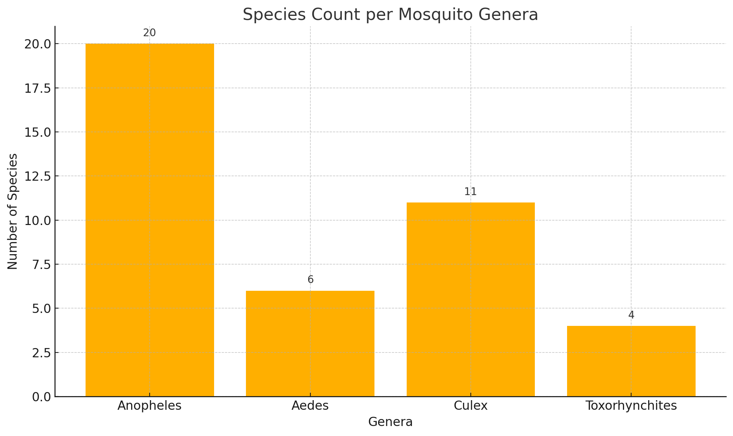

**Table 1: Overview of Mosquito Fauna of Pakistan**

|  |  |  |  |
| --- | --- | --- | --- |
| Family | Sub-Family | Genera | Species |
| Culicidae | ***Anophelinae*** | ***Anopheles*** | 1. An. barbirostris 2. An. barianensis 3. An. stephensi 4. An. culicifacies 5. An. superpictus 6. An. subpictus 7. An. pulcherrimus 8. An. nigerrimus 9. An. maculatus 10. An. lindesayi 11. An. sinensis 12. An. fluviatilis 13. An. minimus 14. An. splendidus 15. An. theobaldi 16. An. annularis 17. An. claviger 18. An. jayporiensis 19. An. sergentii 20. An. Multicolor |
|  | ***Culicinae*** | ***Aedes*** | 1. Ae. aegypti 2. Ae. vittatus 3. Ae. albopictus 4. Ae. caspius 5. Ae. niveus 6. Ae. Vexans |
|  |  | ***Culex*** | 1. Cx. bitaeniorhynchus 2. Cx. gelidus 3. Cx. fuscocephala 4. Cx. perexiguus 5. Cx. quinquefasciatus 6. Cx. pipiens 7. Cx. tritaeniorhynchus 8. Cx. theileri 9. Cx. univittatus 10. Cx. sitiens 11. Cx. Vishnui |
|  | *Toxorhynchitinae* | *Toxorhynchites* | 1. Tx. splendens 2. Tx. amboinensis 3. Tx. brevipalpis 4. Tx. macaensis (Not present in Pakistan) |

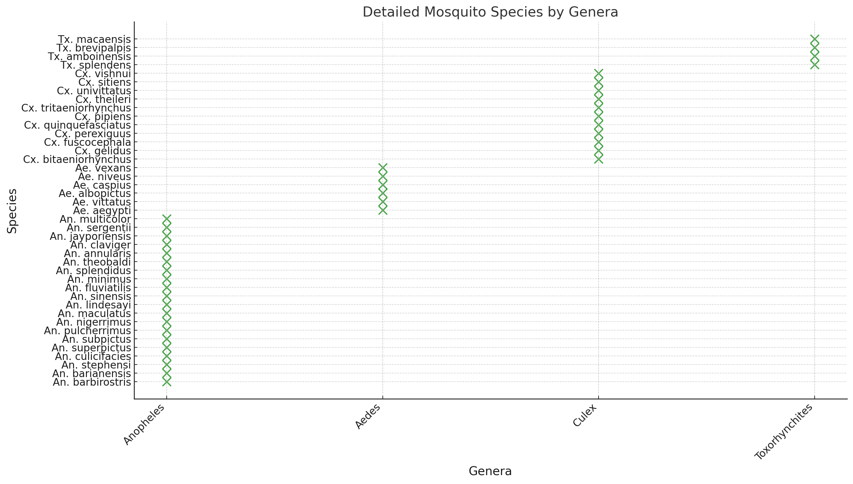

Figure 1: Number of Species in the Culicidae Family

**CONCLUSION**

The mosquito fauna of Pakistan is represented by 3 Genera: Anopheles, Aedes and Culex. It contains 3 subfamilies: (1). *Anophelinae (2). Culicinae (3).Toxorhynchitinae*. The Genus Anopheles includes 20 species such as *An. Annularis, An. culicifacies, An. fluviatilis, An. maculatus, An. pallidus, An. pulcherrimus, An. splendidus, An. Stephensi, An. subpictus.*Aedes genus includes 6 of species Ae. *aegypti, Ae. albopictus, Ae. vittatus, Ae. vexans, Ae. caspius, Ae. niveus. Cx is one of 11 species in the Genus Culex. bitaeniorhynchus, Cx. fuscocephala, Cx. gelidus, Cx. pipiens, Cx. sitiens, Cx. theileri, Cx. tritaeniorhynchusm, Cx. univittatus*. These have been documented from across all provinces in Pakistan. Present study concluded that Lahore, Karachi and Peshawar come under high risk factors for Dengue and Malaria fever. The present survey report will add taxonomy keys for the recognition of mosquitos recorded from Pakistan. Many Sp mosquito fauna which are never identified in Pakistan science gap is filling with this site. The keys rely on literature sources as well as studies of field and museum collections. With the resurgence of malaria and dengue worldwide, there is a require dichotomous keys that need to be stressed. So, the present study will be useful in providing a comprehensive classification tool for various mosquito species in Pakistan.

**REFERENCES**

* Ali, N., Khan, K., and Kausar, A. 2013. Study on mosquitoes of Swat Ranizai subdivision of Malakand. Pakistan Journal of Zoology, **45** (2): 503 – 510.
* Chen, L. H., and Wilson, M. E. 2010. Dengue and chikungunya infections in travelers. Current Opinion in Infectious Diseases, **23** (5): 438 - 444.
* Eamkum, P., Sungvornyothin, S., Kritpetcharat, O., Daduang, J., Lek-Uthai, U., Charerntanyarak, L., and Kritpetcharat, P. 2014. A single-round multiplex PCR assay for the identification of Anopheles minimus related species infected with Plasmodium falciparum and Plasmodium vivax. Parasitology International, **63** (2): 442 - 449.
* Harbach, R. E. 2007. The Culicidae (Diptera): a review of taxonomy, classification and phylogeny. Zootaxa, **1668** (1): 591 - 638.
* Harbach, R. E. 2012. Culexpipiens: species versus species complex–taxonomic history and perspective. Journal of the American Mosquito Control Association, **28** (4): 10 - 23.
* Ilahi, I., and Suleman, M. 2013. Species composition and relative abundance of mosquitoes in Swat, Pakistan. International Journal of Innovation and Applied Studies, **2** (4): 454 - 463.
* Khan, I.A., Din, M.M.U., Hussain, S., Skbar, R., Saeed, M., Farid, A., Fayaz, W. and Shah, R. A., 2015. A study of mosquito fauna of District Upper Dir, Khyber Pakhtunkhwa-Pakistan. Journal of Entomology and Zoology Studies, **3** (5): 455 - 458.
* Kraemer, M., Reiner Junior, R., Brady, O., Messina, J., Gilbert, M., Pigott, D.M., Yi, D., Johnson, K., Earl, L., Marczak, L.B., Shirude, S., Davis Weaver, N., Bisanzio, D., Perkins, T.A., Lai, S., Lu, X., Jones, P., Coelho, G.E., Carvalho, R.G., Van Bortel, W., Marsboom, C., Hendrickx, G., Schaffner, F., Moore, C.G., Nax, H.H., Bengtsson, L., Wetter, E., Tatem, A.J., Brownstein, J.S., Smith, D.L., Lambrechts, L., Cauchemez, S., Linard, C., Faria, N.R., Pybus, O.G., Scott, T.W., Liu, Q., Yu, H., Wint, G.R.W., Hay, S.I. and Golding, N. 2019. Past and future spread of the arbovirus vectors Aedesaegypti and Aedesalbopictus. Nature Microbiology, **4** (5): 854 - 863.
* McMeniman, C. J., Lane, R. V., Cass, B. N., Fong, A. W., Sidhu, M., Wang, Y. F., and O'Neill, S. L. 2009. Stable introduction of a life-shortening Wolbachia infection into the mosquito Aedesaegypti. Science, **323** (5910): 141 - 144.
* Medlock, J. M., Hansford, K. M., Versteirt, V., Cull, B., Kampen, H., Fontenille, D., and Schaffner, F. 2015. An entomological review of invasive mosquitoes in Europe. Bulletin of Entomological Research, **105** (6): 637 - 663.
* Mendki, M. J., Singh, A. P., Tikar, S. N., Parashar, B. D., Veer, V., Shukla, S. V., and Prakash, S. 2015. Repellent activity of N, N-diethylphenylacetamide (DEPA) with essential oils against Aedesaegypti, vector of dengue and chikungunya. International Journal of Mosquito Research, **2** (1): 17 - 20.
* Naeem-Ullah, U., Akram, W., Suhail, A., and Rana, S. A. 2010. Grouping of different mosquito species on the bases of larval habitats. Pakistan Journal of Agricultural Science, **47** (2): 124 - 131.
* Noutcha, M. A. E., and Anumudu, C. I. 2009. Entomological indices of Anopheles gambiaesensulato at a rural community in south-west Nigeria. Journal of Vector Borne Diseases, **46** (3): 43 - 51.
* Reinert, J. F., Harbach, R. E., and Kitching, I. J. 2009. Phylogeny and classification of tribe Aedini (Diptera: Culicidae). Zoological Journal of the Linnean Society, **157** (4): 700 - 794.
* Rueda, L. M. 2008. Global diversity of mosquitoes (Insecta: Diptera: Culicidae) in freshwater. In Freshwater Animal Diversity Assessment. Springer, Dordrecht, **198** (3): 477 - 487.
* Shaikh, S., Kazmi, S. J. H., and Qureshi, S. 2014. Monitoring the diversity of malaria and dengue vectors in Karachi: studying variation of genera and subgenera of mosquitoes under different ecological conditions. Ecological Processes, **3** (1):1 - 9.
* Somboon, P., and Rattanarithikul, R. 2013. Mosquito surveys, rearing, preservation of mosquito specimens and identification of Anopheles in Thailand. Ministry of Public Health, Nonthaburi, Thailand, **47** (2): 79 - 153.
* Somboon, P., Thongwat, D., and Harbach, R. E. 2011. Anopheles (Cellia) rampae n. sp., alias chromosomal form K of the Oriental Maculatus Group (Diptera: Culicidae) in Southeast Asia. Zootaxa, **2810** (1): 47 - 55.
* UD DIN, M. and KHAN, I.A. 2015. Species composition, relative abundance and habitats of mosquito fauna of District Upper Dir, Khyber Pakhtunkhwa-Pakistan. Journal of Entomology and Zoology Studies, **3** (5): 447 - 450.
* Wanji, S., Mafo, F. F., Tendongfor, N., Tanga, M. C., Tchuente, F., Bilong, C. B., and Njine, T. 2009. Spatial distribution, environmental and physicochemical characterization of Anopheles breeding sites in the Mount Cameroon region. Journal of Vector Borne Diseases, **46** (1): 75 - 80