**Barriers and Challenges in Information Seeking: Experiences of Visually Impaired Persons in Rawalpindi and Islamabad**

**Adnan Khan**

[adnan.information.scientist@gmail.com](mailto:adnan.information.scientist@gmail.com)

MS-LIS, Sarhad University Peshawar

**Dr. Ata ur Rehman**

[ata.rahman@iiu.edu.pk](mailto:ata.rahman@iiu.edu.pk)

Assistant Professor, Al-Hamd Islamic University, Islamabad

**Muhammad Jawwad**

[muhammad_jawwad@aiou.edu.pk](mailto:muhammad_jawwad@aiou.edu.pk)

Lecturer, Allama Iqbal Open University, Islamabad

**Syed Arif Ali Shah**

[Arif.lis@suit.edu.pk](mailto:Arif.lis@suit.edu.pk)

Assistant Professor, Sarhad University Peshawar

**Asad Ullah Khan**

[asadullahkhanzada100@gmail.com](mailto:asadullahkhanzada100@gmail.com)

Librarian, Government College Attock

**Corresponding Author: * Adnan Khan** [adnan.information.scientist@gmail.com](mailto:adnan.information.scientist@gmail.com)

**Received:** 05-08-2025 **Revised:** 02-09-2025 **Accepted:** 19-09-2025 **Published:** 07-10-2025

**ABSTRACT**

*Access to information is recognized as a fundamental human right; however, visually impaired persons (VIPs) continue to face significant challenges in exercising this right. These barriers persist largely due to the unavailability of accessible formats, limited access to assistive technologies, and inadequate institutional support systems. The present study investigates these challenges within the context of Rawalpindi and Islamabad, employing Wilson’s Information Behavior Model (1996) as the analytical framework to understand the information-seeking behaviors of VIPs. A structured questionnaire was administered to a sample of 100 respondents to collect data on the specific obstacles faced. The findings revealed several key barriers: a notable lack of accessible information formats such as Braille, audio, and screen-readable digital content; insufficient availability and affordability of assistive technologies; overdependence on intermediaries for information access; undertrained library staff unfamiliar with the needs of VIPs; and financial constraints that hinder access to both resources and support services. These findings point to systemic gaps in the current information provision infrastructure for the visually impaired. To address these, the study recommends the adoption of inclusive library services that prioritize accessibility, expansion in the provision and maintenance of assistive technologies, and comprehensive training programs for librarians and information professionals. Equipping libraries with both the tools and the human capacity to serve VIPs is essential for promoting equitable access to information and ensuring that this fundamental right is upheld for all members of society, regardless of visual ability.*

***Keywords:*** *Visually impaired persons, barriers, information seeking, accessibility, assistive technologies, Pakistan*

**INTRODUCTION**

It is an unquestioned fact that information is a powerful instrument that may be utilized to attain development, education, and social inclusion. When one has access to information, he is better placed to make quality decisions, has the capacity to participate in the democratic processes and can even access education and job opportunities. When it comes to a visual impaired person (VIP) though the process of receiving information is extremely complex and is affected by social, technological as well as infrastructural constraints. It is evident in international literature that blind people are prone to difficult to read formats, online illiteracy, and institutional support. The developed countries have gone a notch higher to aid them to come up with inclusive policies, assistive technologies in addition to awareness campaigns but in most developing countries, there is an issue of fair access to information resources.

These issues are even higher in Pakistan. Assistive technologies like screen reader, magnifiers, and Braille facilities are usually not adequately available in libraries, educational institutions, and other government facilities. A research study conducted by Ahmed and Naveed (2020) indicated that the visually impaired Pakistani students depend greatly on their peers and family members to acquire and understand information. Equally, Ali et al. (2016) reported that visually impaired students in Lahore had problems with obtaining academic resources in accessible formats. Although there is partial acknowledgement of the issues and rights of individuals with disabilities at the policy level, there is a poor implementation practice, and in libraries and academic institutions, there is limited systematic support as well as specific training programs of VIPs.

The lack of available information services is among the factors that make an individual unwelcome in education, employment and communal life. The latter are particularly noticeable in such cities like Rawalpindi and Islamabad where information resources are demanded and not supplied appropriately. The Information Behavior Model by Wilson (1996) is a construct that can be useful in the study of these challenges because it highlights the interaction of individual, social, and environmental elements of information-seeking behavior.

The proposed study is going to be a research that will bridge the research gap by specifically looking at the barriers and challenges of visually impaired persons in Rawalpindi and Islamabad. Through analyzing their experiences, the research is aimed at pointing at failure problems in the system and offer practical suggestions to the policymakers, teachers, and librarians. The importance of such a study is that, it will be able to help in informing the inclusive practices and enhancing the access and provision of information as well as social and educational empowerment of the visually impaired persons in Pakistan.

**LITERATURE REVIEW**

Exploration of information seeking behavior of visually impaired has been widely researched worldwide. In a close-up theorization, Berget and MacFarlane (2020) found several barriers of accessibility peculiar to information systems in a digital format, thus revealing a significant discrepancy between the design of informational resources and the real-life needs of visually impaired individuals (VIPs). Their results show that despite the assumed access to materials, there are challenges like unreadable typography, excessively complex or non-navigable web interfaces, and lack of compatibility with speech-readers that significantly hinder the access to information. In a similar vein, Potnis and Mallary (2021) found out that many academic libraries continue to not consistently offer support to VIPs despite the significant development of assistive technology. The authors referred to this phenomenon as a service divide which means the difference between the declarations of the institutions that provides it and what the actual user of the service gets.

Khowaja and Fatima (2019) have reported a high amount of barriers in Indian universities and that visually impaired students experienced limited access to digital resources, limited Braille facilities, and lacking sufficiently qualified library staff. The authors explained the marginalization of VIPs by the institutional oversights and lack of knowledge. Based on a comparative study, Appiah (2021) examined the cases of visually impaired students in Ghana to conclude that a significant percentage of students depended on peer support and faculty support because of the lack of institutional resources. These empirical data are not unique in this respect because the larger literature assumes that VIPs will often rely on interpersonal relationships instead of institutional procedures to meet their informational requirements (Ullah et al., 2024).

In Pakistan, the empirical history is quite meager but informative. Ali et al. (2016) investigated the information-seeking behavior of visually impaired students in Lahore and indicated that most of them used friends and colleagues as an alternative to the available resources. Ahmed and Naveed (2020) generalized this question to several universities and found out that the major obstacles to pervasive accessibility are the lack of ICT infrastructure, insufficient supply of Braille materials, and the lack of staff training. Together, these researchers outline the systemic barriers that are deeply rooted, preventing the autonomous acquisition of information by individuals with visual impairments.

Although numerous researches have been conducted on this topic, there are numerous gaps in defining what, actually, the visually impaired persons (VIPs) in the urban settings in Pakistan are facing (Islam et al., 2025). Past studies tend to adopt a limited institutional outlook or offer merely a definition of the issue and do not offer more systemic mechanisms that restrict access and create exclusion. The current paper aims to fill this gap by concentrating on Rawalpindi and Islamabad which are the urban hubs boasting of a range of educational and institutional resources but with limited inclusive practices.

Based on the Information Behaviour Model developed by Wilson (1996), the present study provides a systematic explanation of the obstacles and issues that are involved in information-seeking among VIPs in Pakistan. The research thus makes a contribution to the theoretical development as well as actionable recommendations that may be made to create a more inclusive information environment.

**METHODOLOGY**

The research was in type of a quantitative survey. The questionnaire applied was a structured questionnaire that was applied to 100 visually impaired respondents in Rawalpindi and Islamabad through a snowball sampling strategy. The theoretical basis in this case was the Information Behaviour Model presented by Wilson (1996). The analysis of the data was done in SPSS and descriptive statistics served to give a summary of the results. The evaluation of reliability produced Cronbachs alpha of 0.73 which indicated good internal consistency.

# **FINDINGS**

**Table 1: Demographic Profile of Respondents**

|  |  |  |
| --- | --- | --- |
| **Category** | **Frequency** | **Percentage** |
| Gender (Male) | 60 | 60% |
| Gender (Female) | 40 | 40% |
| Age (20–29) | 45 | 45% |
| Age (30–39) | 35 | 35% |
| Age (40+) | 20 | 20% |
| Education (Undergraduate) | 50 | 50% |
| Education (Postgraduate) | 50 | 50% |

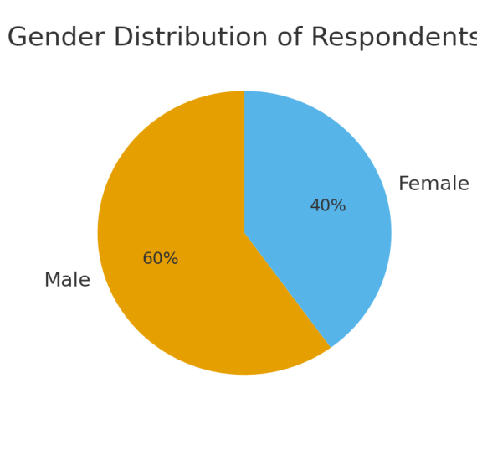

Demographic structure shows that there is a majority of male respondents who constitute around 60 per cent as opposed to female respondents who constitute about 40 per cent. Most of the respondents are between 20 and 39 years of age and the education levels are well balanced between undergraduate and postgraduate levels. Demographics indicate an active population involved in education and career planning.

**Table 2: Barriers Faced by Visually Impaired Persons in Information Seeking**

|  |  |  |
| --- | --- | --- |
| **Barrier** | **Frequency** | **Percentage** |
| Inaccessible Formats | 85 | 85% |
| Lack of Assistive Technologies | 70 | 70% |
| Dependence on Intermediaries | 65 | 65% |
| Untrained Staff | 55 | 55% |
| Financial Constraints | 50 | 50% |

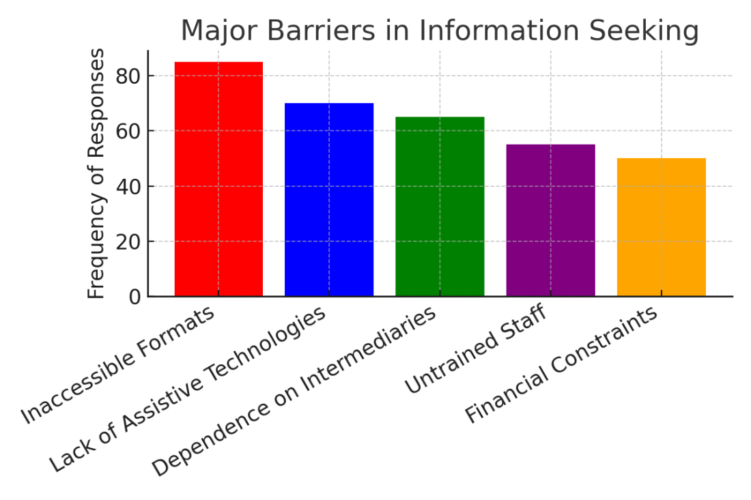

The first barrier, as identified, was the lack of available formats where 85 percent of the respondents cited the lack of this, followed by insufficient assistive technologies, cited by 70 percent of the respondents. A significant percentage of participants, 65 percent, said they used intermediaries, including friends or family members to access information. Moreover, the low quality of personnel training in libraries, cited by 55 percent of those surveyed, and financial limitations, mentioned by 50 percent, also hindered access to information generally. These results highlight structural deficiencies in institutional service and a dire need to establish inclusive information services.

## DISCUSSION

The collected empirical evidence suggests that visually impaired people (VIPs), who live in Rawalpindi and Islamabad, face serious obstacles in retrieving information, and the most prominent threats in this respect are the prevalence of inaccessible forms and the absence of assistive technologies. These findings are consistent with the literature in the whole world. Berget and MacFarlane (2020) remarked that in Europe, digitally disadvantaged individuals with visual disabilities are always faced with information accessibility challenges, regardless of the presence of information resources. Likewise, Potnis and Mallary (2021) discovered that academic libraries in the United States continue to lack the assurance of stable assistive technologies and leave the institutional proclamations and user experiences at variance. These observations are in line with the findings of this study, in that accessibility is not only a technical issue but a system-wide problem which needs institutional changes.

Khowaja and Fatima (2019) also found that in the South Asian environment, there was no infrastructure or trained personnel to attend to VIPs in Indian universities and they had to depend extensively on peers. Similar findings were achieved in this study with 65 per cent of Pakistani respondents indicating that they were dependent on the intermediaries they used like friends and family. Besides being a hindrance to the autonomous seeking of information, this dependency is also a hindrance to privacy and autonomy, which is the key to personal empowerment.

Half of the respondents also pointed out the problem of financial constraints. It is also not exceptional to Appiah (2021), who observed that in Ghana, students with visual impairments were unable to afford assistive tools, which resulted in an over-dependence on institutional provisions. Pakistan ensures that the cost of personal assistive technology like JAWS or NVDA is expensive, which is aggravated by the lack of government subsidies. The results also align with the study of Ahmed and Naveed (2020), which found that the insufficient ICT infrastructure and the financial support in the form of lacking funds appeared to be the major obstacles to the visually impaired students of Pakistani universities.

The other valuable discovery is associated with the problem of lack of trained personnel. Another finding in this study was that 55 percent of the participants believe that the library professionals were not trained on how to assist the visually impaired users. The same problem was also found in the institutions of Lahore by Ali et al. (2016). The absence of the professional training does not only decrease the usability of supplied resources but also deters VIPs to use library services at all. Libraries worldwide are trending towards specialized staff training and policies of inclusive service (Wentz et al., 2020), which proves that the latter can be removed under the condition of adequate institutional investment.

Conclusively, the paper affirms that the problems facing the Pakistani VIPs are essentially structural and cultural. Despite increasing trends of an inclusive information space in developed countries, Pakistan is still being pushed to sidelines due to poor policy frameworks, inadequate funding and lack of awareness. These VIPs are likely to feel marginalized in their endeavor of acquiring education, career progression and social engagement until these systemic impediments are appropriately addressed.

**CONCLUSION**

The current research paper has looked into the problems and limitations facing visually impaired persons (VIPs) in Rawalpindi and Islamabad in information acquisition. Results indicated that the most important barriers were format inaccessibility, inadequate accessibility to assistive technologies, intermediaries, poorly trained library staff, and financial constraints. These challenges indicate how systemic, technical, and socio-economic factors intersect to limit the ability of the visually impaired to engage in autonomous information seeking practices.

Compared to the research on the same topic in various countries, the events in Pakistan seem to be worse because of the weak implementation of the policy, the absence of awareness, and financial and institutional support. Such barriers not only deny visually impaired individuals their right to information but also continue to exclude the disabled in the fields of education, employment and social life.

The research has a theoretical and practical contribution. In principle, it uses the Information Behaviour Model by Wilson (1996) to place the experiences of Pakistani VIPs. In practice, it provides knowledge to librarians, policymakers and education centers so as to develop inclusive services. With such barriers being addressed, the stakeholders will be able to empower VIPs so that they can become significant players in education, employment and the society in general.

**RECOMMENDATIONS**

Easy Availability of Information Resources: Academic institutions and libraries should make sure that their material is available in accessible formats such as Braille, audiobooks, tattoos, and screen-reader-friendly e-resources.

**Enlargement of Assistive Technologies**: Universities and libraries need to install and maintain assistive software, including JAWS and NVDA and magnification software, hardware including Braille embossers, smart canes.

**Training of the Library Staff**: Training of the library staff to work with the visually impaired users should be done continuously through professional development programmes so that the librarians and staff can be able to support the users effectively.

**Financial Assistance and Subsidies**: Government needs to provide special funds or subsidies to assistive devices in order to lessen the economic burden of visually impaired children studying.

**Policy Reforms and Implementation**: The rights of VIPs should be explicitly covered by the national education and information policies and this must be monitored and properly held accountable.

**Information and Digital Literacy Programs:** The visually impaired persons should receive regular training workshops that are customized to ensure that they have improved ICT and research skills so that they can seek information independently.

**Collaborative Initiatives**: Universities, NGOs, disability-rights organisations and government agencies ought to work together to develop sustainable programmes which can effectively support the long term needs of VIPs.

**Awareness and Advocacy Campaigns**: There should be awareness campaigns to create awareness among the people, teachers and the policy makers towards the needs and potential of the visually impaired persons and eliminate social stigma, discrimination.

## REFERENCES

Ahmed, S., & Naveed, M. A. (2020). Accessibility of information resources for visually impaired university students in Pakistan. Library Philosophy and Practice.

Ali, N., Bashir, S., Fatima, S., & Babar, M. (2016). Information seeking behavior of visually impaired students in Lahore. Pakistan Journal of Information Management.

Appiah, K. (2021). Information seeking among visually impaired students in Ghana. Journal of Information Science, 47(3), 321–334.

Berget, G., & MacFarlane, A. (2020). Accessibility and information seeking: Barriers for persons with visual impairments. Information Research, 25(2), 1–17.

Fatima, S., & Qureshi, R. (2022). Accessibility of academic libraries for students with disabilities in Pakistan. Library Review, 71(3), 199–213.

Hussain, I., & Safdar, M. (2018). Challenges of inclusive education in Pakistan: A case study of visually impaired students. Pakistan Journal of Education, 35(1), 59–72.

Islam, K., Shamshad, A., & Usman, M. (2025). Adoption Potential of Artificial Intelligence and Machine Learning in Islamabad’s Academic Libraries. *Journal of Engineering and Computational Intelligence Review*, *3*(1), 12-24.

Khan, H., & Jabeen, F. (2022). Accessibility of higher education for students with disabilities in Pakistan. Asian Journal of Inclusive Education, 10(1), 22–34.

Khowaja, K., & Fatima, N. (2019). Challenges of visually impaired students in higher education. International Journal of Library and Information Studies, 9(2), 45–55.*

Mahmood, K., & Rehman, S. U. (2019). Barriers to information access for persons with disabilities in Pakistan. Library Philosophy and Practice.

Malik, S., & Ahmad, A. (2021). Use of assistive technologies among visually impaired students in Punjab. Pakistan Journal of Special Education, 16(2), 101–115.

Potnis, D., & Mallary, K. (2021). Barriers to assistive technology use in academic libraries. College & Research Libraries, 82(6), 915–936.

Rauf, A., & Gul, S. (2023). Perceptions of accessibility services in academic libraries of Pakistan. Journal of Library and Information Services, 14(1), 88–102.

Saeed, M., & Asghar, H. (2023). Digital inclusion for visually impaired learners: Challenges in developing countries. Journal of Information & Communication Technology, 17(2), 145–160.

Ullah, A., Islam, K., Ali, A., & Baber, M. (2024). Assessing the impact of social media addiction on reading patterns: A study of Riphah International University students. *International Journal of Human and Society*, *4*(1), 1250-1262.

UNESCO. (2020). Education and disability: Analysis of data and global commitments. Paris: UNESCO.

Wentz, B., Jaeger, P. T., & Lazar, J. (2020). Digital accessibility and information equity for people with disabilities. Library Quarterly, 90(2), 125–144.

World Bank. (2022). Disability inclusion and education in South Asia: A policy review. Washington, DC: World Bank.

World Health Organization. (2021). World report on vision. Geneva: WHO.